LABORATORY OBSERVATION/RECORD
Course: Full Stack Web Development
Course Code: 23CM4121
Task No.: 3
Student Name: EMANDI HARI CHARAN
Roll No.: A24126552080
Date:

1. TITLE
Dynamic To-Do List Application Using JavaScript DOM
2. AIM
To design and develop an interactive To-Do List web application using HTML5, CSS3, and JavaScript DOM manipulation to manage dynamic task additions, state toggling (completion with strikethrough), task removal, and real-time empty state visibility handling without refreshing the webpage.
3. OBJECTIVE
The objectives of this experiment are:
- To understand and implement client-side Document Object Model (DOM) selection using getElementById().
- To dynamically generate and configure new HTML elements (document.createElement) at runtime.
- To attach dynamic event listeners and onclick handlers to dynamically created UI components.
- To modify element class lists dynamically (classList.toggle) to update visual presentation.
- To safely remove nodes from the live DOM tree using li.remove().
- To validate user inputs and automatically toggle conditional display elements based on list child count.
4. THEORY
The Document Object Model (DOM) is an object-oriented representation of an HTML document, structured as a logical tree of nodes. Every HTML tag, attribute, and text block is represented as a node object that JavaScript can query, inspect, modify, or delete.
Dynamic DOM manipulation in this application implements the following lifecycle:
- • Input Validation: Inspects the value property of taskInput; if empty, prompts an alert to guarantee input integrity.
- • Node Creation: Invokes document.createElement('li') and document.createElement('button') to assemble interactive task items dynamically in memory.
- • Tree Insertion: Attaches child buttons to the <li> and appends the <li> to the parent <ul> container via appendChild().
- • State Toggling: Toggles the '.completed' CSS class (text-decoration: line-through) upon clicking the Complete button.
- • Node Deletion: Calls li.remove() to purge the targeted element from memory and updates the empty-state indicator if children count hits zero.
Data Flow:
User Event (Click 'Add Task') → Input Sanitization → DOM Node Creation (li, button) → DOM Tree Mutation (appendChild) → Event Listener Binding → UI Render
5. ALGORITHM / PROCEDURE
1. Create index.html: Define input container with <input type='text' id='taskInput'> and <button id='addTask'>.
2. Add an empty-state paragraph <p id='emptyMessage'>No tasks available.</p> and an empty task list <ul id='taskList'>.
3. Define CSS rules for card layouts, buttons (.complete in blue, .delete in red), and completed state (.completed with line-through).
4. Create Script.js: Select target DOM nodes using document.getElementById().
5. Attach onclick handler to addTask: Read taskInput.value.trim(). If empty, alert 'Please enter a task' and return.
6. Create <li> element, assign innerHTML = task. Create 'Complete' button with onclick handler toggling li.classList.toggle('completed').
7. Create 'Delete' button with onclick handler calling li.remove(). If taskList.children.length === 0, set emptyMessage.style.display = 'block'.
8. Append Complete and Delete buttons to <li>; append <li> to taskList; clear input field; hide emptyMessage.
9. Test task addition, completion toggle, deletion, and empty state message toggling in browser.
6. PROGRAM
index.html
<!DOCTYPE html>
<html>
<head>
<title>My To-Do List</title>
<style>
body {
font-family: Arial;
background-color: #f2f4f8;
text-align: center;
margin-top: 50px;
}
h1 {
color: #333333;
}
.input-section {
margin: 20px;
}
input {
padding: 10px;
width: 250px;
border: 1px solid #cccccc;
border-radius: 5px;
}
#addTask {
padding: 10px 15px;
background-color: #4CAF50;
color: white;
border: none;
border-radius: 5px;
cursor: pointer;
}
#addTask:hover {
background-color: #45a049;
}
#emptyMessage {
color: #777777;
}
ul {
list-style-type: none;
padding: 0;
}
li {
background-color: white;
margin: 10px auto;
padding: 10px;
width: 400px;
border-radius: 5px;
box-shadow: 0 2px 5px #cccccc;
}
.complete {
margin-left: 15px;
padding: 5px 10px;
background-color: #2196F3;
color: white;
border: none;
border-radius: 4px;
cursor: pointer;
}
.delete {
margin-left: 5px;
padding: 5px 10px;
background-color: #f44336;
color: white;
border: none;
border-radius: 4px;
cursor: pointer;
}
.complete:hover {
background-color: #1976D2;
}
.delete:hover {
background-color: #d32f2f;
}
/* Completed task */
.completed {
text-decoration: line-through;
color: #888888;
}
</style>
</head>
<body>
<h1>My To-Do List</h1>
<div class="input-section">
<input type="text" id="taskInput" placeholder="Enter a task">
<button id="addTask">Add Task</button>
</div>
<p id="emptyMessage">No tasks available.</p>
<ul id="taskList"></ul>
<script src="Script.js"></script>
</body>
</html>

Script.js
let taskInput = document.getElementById("taskInput");
let addTask = document.getElementById("addTask");
let taskList = document.getElementById("taskList");
let emptyMessage = document.getElementById("emptyMessage");
addTask.onclick = function () {
let task = taskInput.value;
if (task == "") {
alert("Please enter a task");
return;
}
// Create task
let li = document.createElement("li");
li.innerHTML = task;
// Create Complete button
let completeButton = document.createElement("button");
completeButton.innerHTML = "Complete";
completeButton.className = "complete";
// Complete task
completeButton.onclick = function () {
li.classList.toggle("completed");
};
// Create Delete button
let deleteButton = document.createElement("button");
deleteButton.innerHTML = "Delete";
deleteButton.className = "delete";
// Delete task
deleteButton.onclick = function () {
li.remove();
if (taskList.children.length == 0) {
emptyMessage.style.display = "block";
}
};
li.appendChild(completeButton);
li.appendChild(deleteButton);
taskList.appendChild(li);
taskInput.value = "";
emptyMessage.style.display = "none";
};

7. CODE EXPLANATION
Code / Component | Explanation
document.getElementById(id) | Selects and returns a specific DOM element matching the specified unique ID attribute.
taskInput.value | Retrieves the current string data entered by the user into the text input control.
document.createElement('li') | Instantiates a new HTML list item element node in memory before DOM insertion.
button.className = 'complete' | Assigns pre-styled CSS classes to dynamically created button elements.
li.appendChild(element) | Appends a child node element as the last child to the parent <li> container.
li.classList.toggle('completed') | Toggles the presence of the 'completed' class on the target element dynamically.
li.remove() | Removes the targeted <li> node directly from the Document Object Model tree.
taskList.children.length | Returns the active count of child elements present within the task list container.
emptyMessage.style.display | Dynamically toggles CSS display property between 'none' and 'block' based on task count.

8. TEST CASES AND EXECUTION DATA
Test Case | Input Name | Test Input | Expected Result | Actual Result | Status
TC-01 | Initial Empty View | Page load | 'No tasks available.' text displayed; list is empty | Displayed correctly | Pass
TC-02 | Empty Input Validation | Click 'Add Task' with empty input | Browser alert prompt: 'Please enter a task' | Alert displayed | Pass
TC-03 | Task Addition | Input: 'Complete Full Stack Assignment' | New task <li> created with Complete & Delete buttons | Task added cleanly | Pass
TC-04 | Complete Task | Click 'Complete' button | Task text struck through with line-through styling | Strikethrough applied | Pass
TC-05 | Uncomplete Task | Click 'Complete' button again | Strikethrough removed from task text | Class toggled off | Pass
TC-06 | Delete Task | Click 'Delete' button | Target task removed from DOM; empty message toggles if empty | Removed cleanly | Pass

9. OUTPUT
Output 1: Dynamic To-Do List Application Execution (Initial Empty & Interactive States)
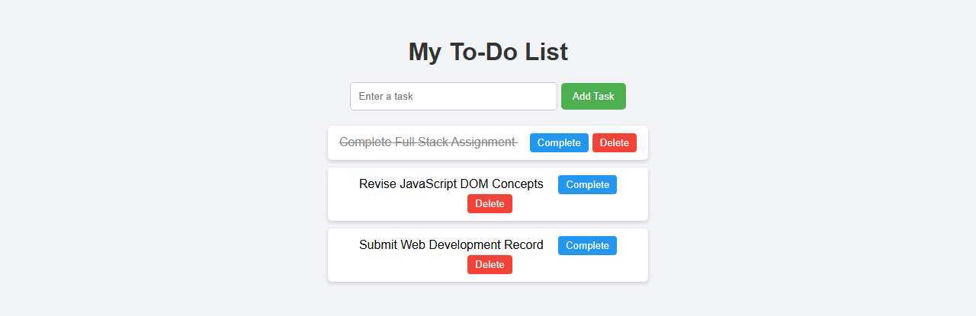
10. RESULT
Thus, the dynamic To-Do List web application was successfully designed, developed, and verified using JavaScript DOM manipulation. Element creation, dynamic event binding, CSS class toggling, node removal, and conditional empty-state handling functioned accurately across all test cases.

